Networks / PCA / connectedness: GBPUSD and USDCHF
Method 28 / pair slice of eight-major system / Alpari D1 full available history

Study setup
Logical pair: GBPUSD , USDCHF
Broker symbols: GBPUSD_i , USDCHF_i
Snapshot: 2026-11-03_majors_alpari_D1
Timeframe: D1
Matched return window: 1999-01-05 to 2026-11-02 (UTC bar dates)
Matched return count n: 7201
System panel n: 7127
Dropped unfinished last bar dated 2026-11-03 UTC after a tick-volume check against the prior complete day.
VAR lag (BIC): 1; GFEVD horizon H=10
System TCI: 54.0425
Complete matched rows (Excel): GBPUSD-USDCHF_Network_D1.xlsx

Method carried forward
Three system-level tools on the eight-major daily log-return panel. (1) Network distance d_ij = sqrt(2*(1-rho_ij)) from Pearson correlation. (2) PCA eigenvalues of the correlation matrix R (R v = lambda v). (3) Diebold-Yilmaz total connectedness index (TCI) from a VAR with generalised forecast-error variance decomposition (GFEVD), horizon H=10; lag order chosen by BIC with maxlags=10. TCI = 100 * sum_{i!=j} theta_tilde_ij / N after row-normalising GFEVD shares. Pair reports show d_ij, rho_ij, and the directed pair spillover shares from the system theta_tilde matrix. Edges and TCI are not trading signals.

Pair results
Pearson rho: -0.484413
Network distance d_ij: 1.723028
theta_tilde[GBPUSD->USDCHF] (row GBPUSD, col USDCHF): 0.088578
theta_tilde[USDCHF->GBPUSD] (row USDCHF, col GBPUSD): 0.095088
PCA lambda_1: 3.817794
PCA variance share PC1: 0.477224

Conclusion
For GBPUSD-USDCHF: d_ij=1.7230 from rho=-0.4844. Pair spillover shares 0.0886 / 0.0951. System TCI=54.04. Not a trading signal.

Pair charts
Daily closes

Daily log returns
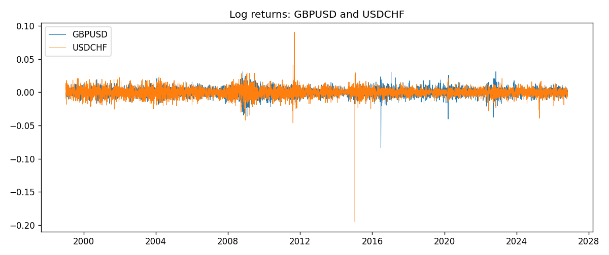

System charts (shared)
Correlation matrix

Distance matrix

PCA eigenvalues

GFEVD theta_tilde


Data report
First 15 matched rows
time | GBPUSD_log_return | USDCHF_log_return
1999-01-05 | -0.0028966287 | 0.0039424743
1999-01-06 | -0.00060452184 | 0.013605652
1999-01-07 | -0.002118709 | -0.0093883841
1999-01-08 | -0.0058954193 | 0.011040268
1999-01-11 | -0.0056851331 | 0.0052963193
1999-01-12 | 0.0022657001 | -0.0098275602
1999-01-13 | 0.0091330396 | -0.018259701
1999-01-14 | 0.0019376331 | -0.0024256692
1999-01-15 | -0.0017558204 | 0.01794228
1999-01-18 | 0.0012112405 | -0.0031856384
1999-01-19 | 0.0018745281 | -7.2518946e-05
1999-01-20 | -0.0049053846 | 0.0072259871
1999-01-21 | 0.0031518998 | -0.0038232689
1999-01-22 | 0.0024781662 | -0.0001445609
1999-01-25 | 0.0012066366 | 0.0024546976
Last 15 matched rows
time | GBPUSD_log_return | USDCHF_log_return
2026-10-13 | 0.0036434319 | -0.0024955621
2026-10-14 | -0.0049164679 | 0.0029388325
2026-10-15 | 0.0065976411 | -0.0097855323
2026-10-16 | 0.0037592051 | -0.0036230826
2026-10-19 | -0.0017500314 | 0.0036351779
2026-10-20 | 0.0055923442 | -0.0026281224
2026-10-21 | 0.0012476328 | -0.00040027413
2026-10-22 | 0.00022396082 | -0.0048036381
2026-10-23 | -0.0021146949 | 0.005652514
2026-10-26 | -0.0024340661 | 0.0018407959
2026-10-27 | -0.0023648393 | 0.0026100526
2026-10-28 | 0.0015771808 | -0.0010142111
2026-10-29 | 0.0035881935 | -0.0048680164
2026-10-30 | 0.0013450605 | 0.00071594559
2026-11-02 | 0.0010971256 | -0.0071459744

